Ideation Phase

Date | 05 October 2026
Team ID | SWTID-2026-4458
Project Name | Import Data using Transform Maps (Spreadsheet)
Team Leader | Monika B
Team Members | D Keerthana, Chandhana S, Vemalaraju Poojitha, Subasri R
Maximum Marks | 4 Marks
Brainstorm & Idea Prioritization Template:
Brainstorming provides a free and open environment that encourages everyone within a team to participate in the creative thinking process that leads to problem solving. Prioritizing volume over value, out-of-the-box ideas are welcome and built upon, and all participants are encouraged to collaborate, helping each other develop a rich amount of creative solutions.
Use this template in your own brainstorming sessions so your team can unleash their imagination and start shaping concepts even if you're not sitting in the same room.
Reference: https://www.mural.co/templates/brainstorm-and-idea-prioritization
Step-1: Team Gathering, Collaboration and Select the Problem Statement
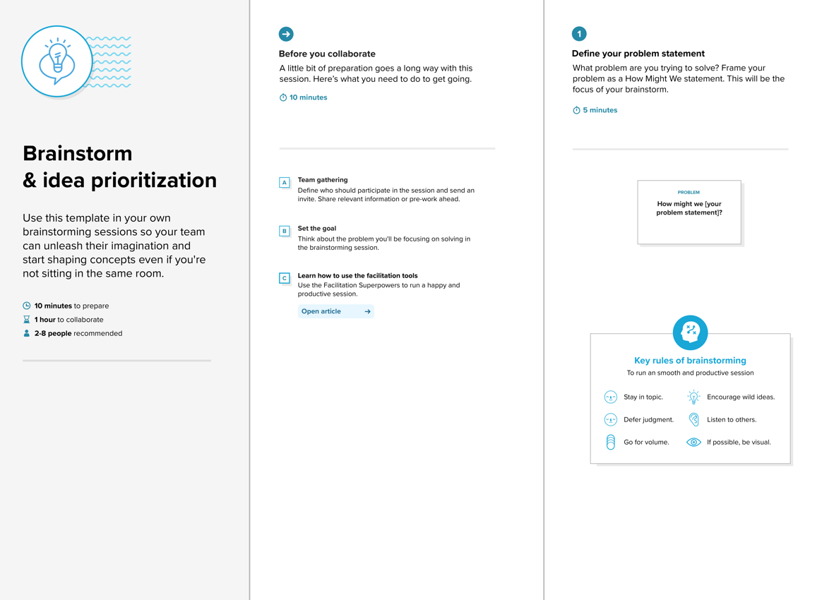

Our Team Gathering & Selected Problem Statement
Team Member | Role in Brainstorming
Monika B (Team Leader) | Facilitator; owns the selected problem statement and final decisions
D Keerthana | Ideas on the spreadsheet source and loading data into the Import Set table
Chandhana S | Ideas on Transform Map field mapping and the Employee ID coalesce setting
Vemalaraju Poojitha | Ideas on testing, validation and data quality
Subasri R | Ideas on result verification, reports and documentation
Selected Problem Statement: Administrators receive employee data (Employee ID, Name, Email, Department and Location) in Excel format and need to load it into ServiceNow in bulk, so that existing employees are updated and new employees are added accurately, without manual entry or duplicate records.
Step-2: Brainstorm, Idea Listing and Grouping
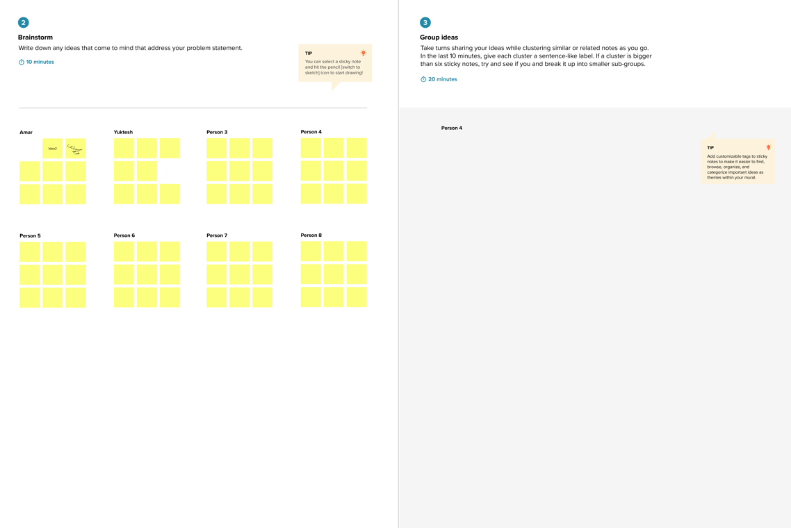
Our Ideas, Listed and Grouped
Group | Ideas
Import Set: Data loading | Upload the Excel spreadsheet using Load Data into an Import Set table  Use the Import Set table as a staging area for temporary processing and validation  Keep spreadsheet column headers clear so they load as source fields
Transform Map: Field mapping | Map Employee ID, Name, Email, Department and Location to the Employee table fields  Use Auto Map Matching Fields, then review each mapping manually  Select the correct target table in the Transform Map
Transform Map: Coalesce | Set Employee ID as the coalesce field (unique identifier)  Update the record when the Employee ID already exists  Insert a new record when the Employee ID is not found
Data quality and validation | Remove blank and duplicate Employee IDs from the spreadsheet before upload  Check that email addresses and department values are in a valid format  Test with a small sample file before the full import
Verification and reporting | Review the transform history for inserted, updated and ignored counts  Open the target table and compare records with the spreadsheet  Create reports and a dashboard (for example, employees by department and location)

Step-3: Idea Prioritization
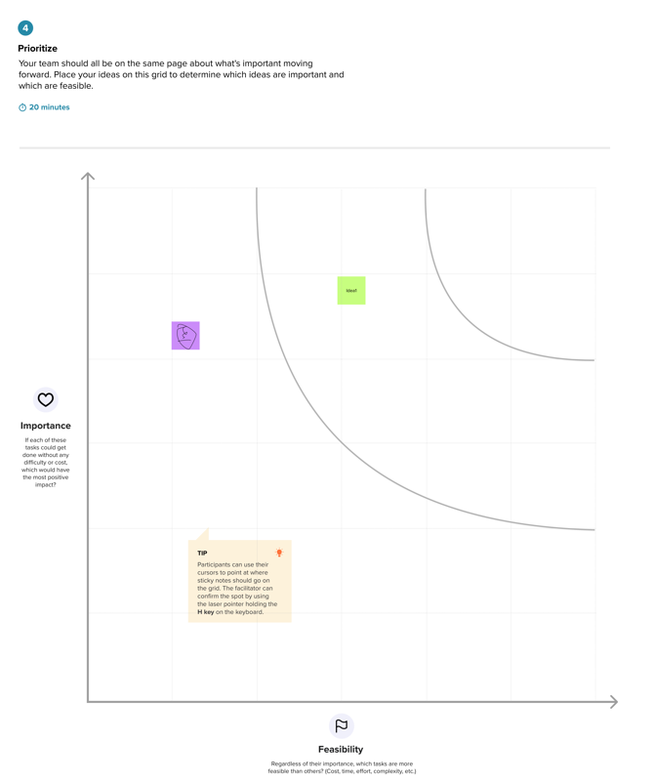
Our Idea Prioritization
Idea | Impact | Effort | Priority / Decision
Load spreadsheet into the Import Set table | High | Low | Do first (core import)
Map fields in the Transform Map | High | Low | Do first (core import)
Employee ID as coalesce field (update existing, insert new) | High | Low | Do first (core import)
Verify records in the target table and transform history | High | Low | Do first (core import)
Clean data before upload (blank and duplicate IDs) | Medium | Low | Do next
Reports for employees by department and location | Medium | Medium | Do next
Employee analytics dashboard | Low | Medium | Later
Outcome: the team will first build the core import (Import Set table, Transform Map field mapping and Employee ID coalesce, then verification of the records), then add data validation, reports and the dashboard for accuracy and insight.

